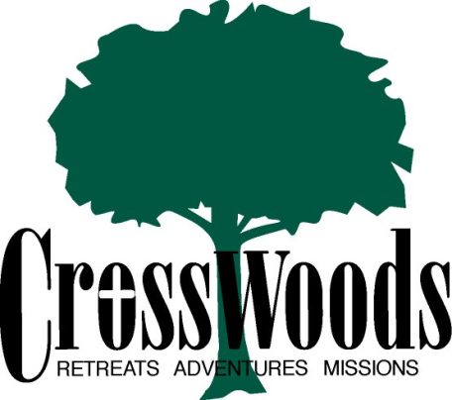

CrossWoods Adventure Camp, LLC,
Family Camp Weekend Schedule
Friday
1:00-6:00pm Arrival (Welcome, orientation, prayer with each family)
2:00pm Afternoon Adventure (Water Wars or Archery Tag or Low Ropes)
4:00pm Free Time (swim, fish, camp store, arts/crafts, Aspen game center/rock wall climb)
6:00pm Dinner
7:00pm Welcome Session (large group) and Family in Faith Speaker
8:00pm Small groups / Activities
9:00pm Bonfire, Praise & worship by campfire, Smore’s, Night Prayer
10-11pm (or earlier) Bedtime, Quiet Time
Saturday
8:00am Morning Prayer
8:30am Breakfast
9:30am Ruckus/Praise & Worship, Gather & Send
10:00am Offsite Adventure (Kayaking including lunch and swim at lunch site, on river)
3:00pm Return to camp, showers, Free time (swim, crafts, fishing, hiking, games in Aspen, camp store, scavenger hunt)
5:30pm Dinner
6:30pm Witness Talk and Faith Activities, God at Camp/God at Home, Who are the Saints? Who is my Guardian Angel?, The Power of Prayer
7:30pm All Camp Game
9:00pm Bonfire, Praise & Worship by Camp Fire, Popcorn, Night Prayer
10-11p Lights Out, Quiet Time
Sunday
7:30am Morning Prayer
8:30am Mass (at St. Anne’s in Cable, WI – 20 min drive)
10:00am Brunch
11:00 am Closing Session/Prayer/Goodbyes
12:00 Noon Pack and Depart (Bag lunches available for return trip home – upon request when you register).

Extra’s:
We recommend lunch on the way up or home - at Delta Diner – which is a ~10 min drive from our camp or at Rivers Eatery in Cable, WI. There are many possible lunch stops in Hayward, WI, Spooner, WI, Turtle Lake, MN (all on Highway 63 heading south from camp).
Arts/Crafts include: Tie Dye, Ice Cream Making, Candle Making (bring your own t-shirt to tie dye)
Free Time Activities: bring your own fishing pole and bait. Hiking shoes recommended as there are 220 acres of hiking trails on camp site.
Life Jackets are available but bring your own if you need adult XL or larger or 7-8yo or younger/smaller/toddler size). PFD’s (personal flotation device) are worn at all times by all persons while in/by water including fishing, swimming, kayaking, canoeing.

