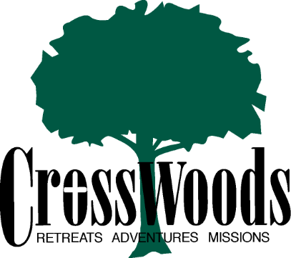

Thank you for your interest in joining the CrossWoods team this summer!
If you’re interested in a Christian high-adventure experience, we’re interested in talking to you about spending your summer with CrossWoods. Located in the heart of the Chequamegon National Forest of northern Wisconsin, CrossWoods’ 220 acre wilderness center is an ideal base for high-adventure ministry. Facilities include group cabins overlooking one of our two private lakes, a dining hall, meeting lodge, high & low ropes courses, an outdoor chapel, campfire rings and miles of hiking and mountain biking trails. Our program also includes off site adventures such as rock climbing & rappelling, mountain biking and whitewater canoeing/kayaking on the Brule River. Morning and evening programing includes praise and worship music, skits, talks and small groups, all helping students make the connection between the adventure activities and their faith journey. Your summer with CrossWoods will challenge you physically as well as spiritually. Are you up for the challenge?

To be considered for a staff position you will need to complete the following steps:

- APPLICATION - Fill out the attached application and mail it to me at the address listed below.

Applications will be accepted until March 1, 2023.

- INTERVIEW - A personal interview is preferred. This can be arranged via email or phone. If a personal interview is not possible, a phone interview may be scheduled.

- CERTIFICATIONS – Must be First Aid/CPR certified through the American Red Cross or American Heart Association (some courses can be completed online, then send us your certification with this application form)
**Staff selections will be made during the first week of March. We will contact you at that time (or before) to inform you of your status.

If you have other questions about the application process, please feel free to give me a call at (651) 212-8617.
Shelby Saenger
Adventure Camp Director

Please send applications to my email (Shelby)
kaufers2386@gmail.com

Or mail to my address:
Shelby Saenger
N4931 710th Street
Ellsworth, WI 54011

CrossWoods Staff Application

Personal Information
Full Name: Social Security #:
Birth Date: Sex: M F
School/Current Address:
City: State: Zip:
Phone: ( ) E-mail:

Home Information
Parent(s):
(if you are a student or a dependent)
Address:
City: State: Zip:
Phone: ( ) E-mail:
Home Church:

Educational Background-(post high school)

School(s) attended Years attended Major Grad date

Camping Background (as camper and/or staff)

Camp Name Dates Length of stay Staff position

Time Commitment

I am able to attend all of staff training from May 31-June 11, 2023: Yes No
If “no”, please explain:

I am able to work the entire camping season from June 11 to August 12, 2023: Yes No
If “no”, please explain:

Certifications
Certification/License Expiration date State
ARC Lifeguard
ARC Water Safety Instruction
ARC First Aid
ARC CPR
ARC First Responder
Wilderness Emergency Training
EMT
Bus License
Other(s)

References

Please list two references (not relatives).
1. Name: Phone: ( )

Relationship:

2. Name: Phone: ( )

Relationship:

Skills and Interests
Please circle the areas in which you are skilled and underline the areas that you have had some experience:

singing | pottery | photography | canoeing | sailing
rock climbing | horseback | lead worship | maintenance | clowning
drama | outdoor cooking | backpacking | kayaking | mountain biking
carpentry | Enviro. Ed | Astronomy | public speaking | guitar
lead Bible study | lead singing | lead games | fishing | ropes course
Musical instruments(list): |  |  | Other:

Please answer the following questions on a separate sheet:

- Briefly describe yourself . . .

- How is your faith expressed in your daily life?

- What are your goals for the summer?

- What is the most meaningful experience that has affected your faith?

- Anything else you want to share . . .

